Internal user’s pages

1. Generate PA section:
2. 1st look:

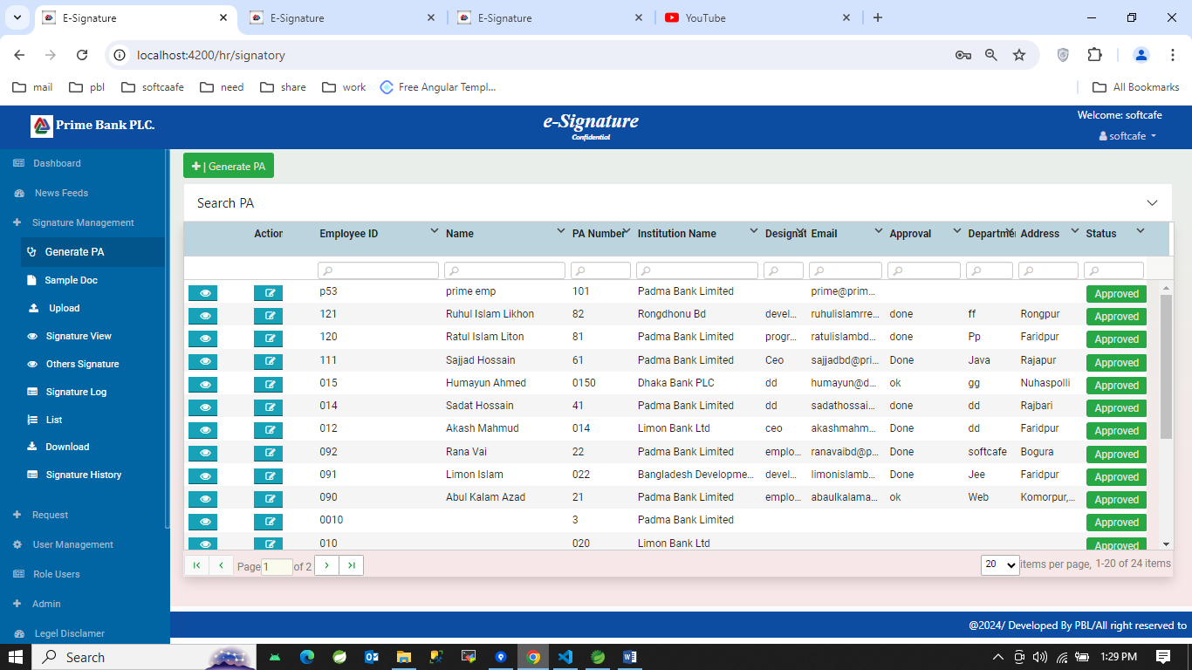

1. 2nd look: clicking Search PA option:

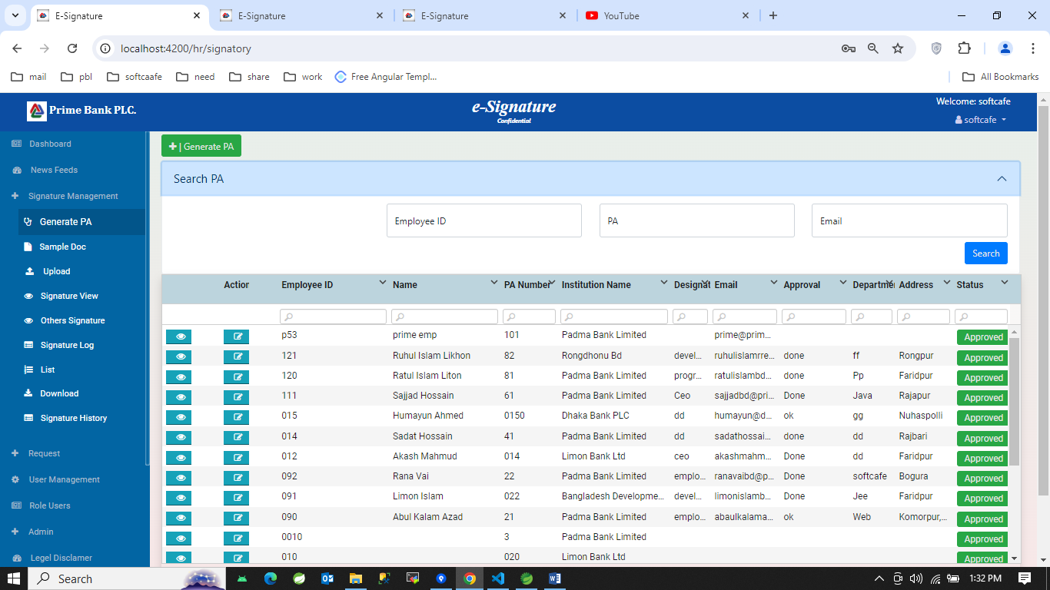

1. Clicking Generate PA button and selecting Prime bank in Bank option:

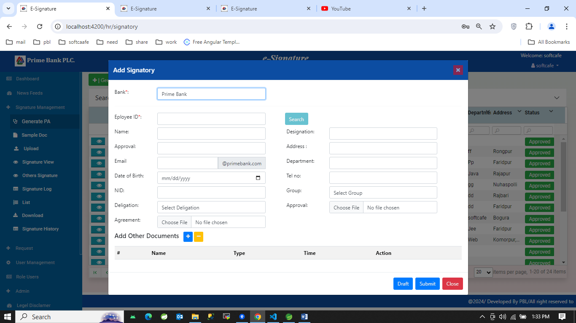

1. Clicking Generate PA button and selecting option in Bank option and selecting Institution type and institution:

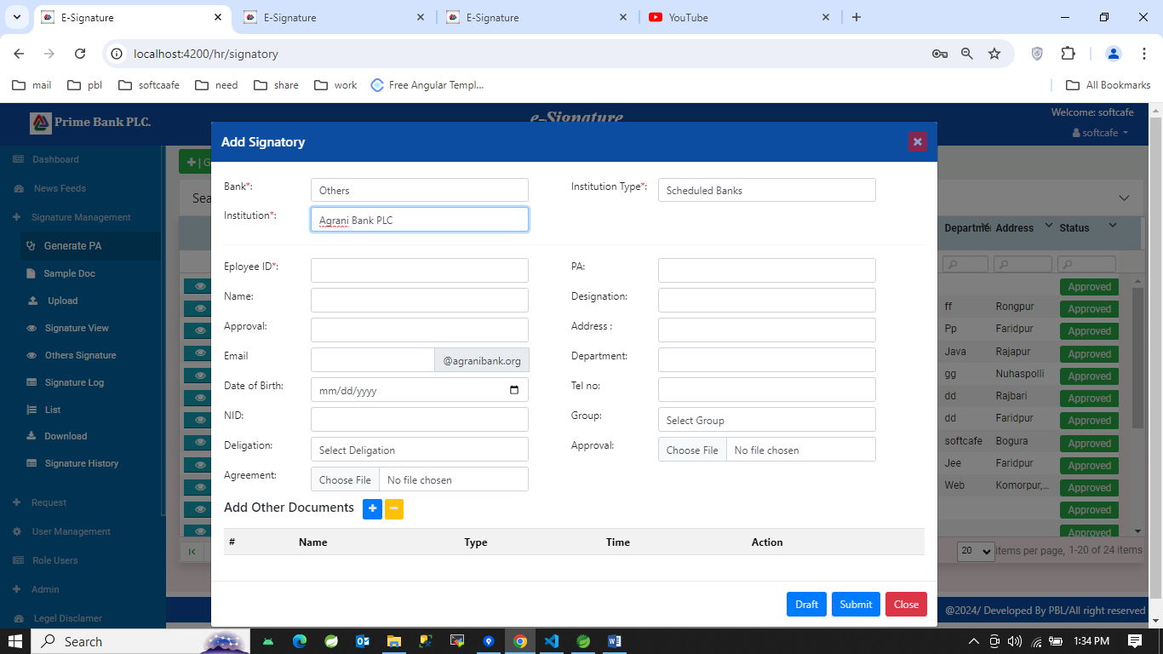

1. Sample doc section:
2. 1st look:

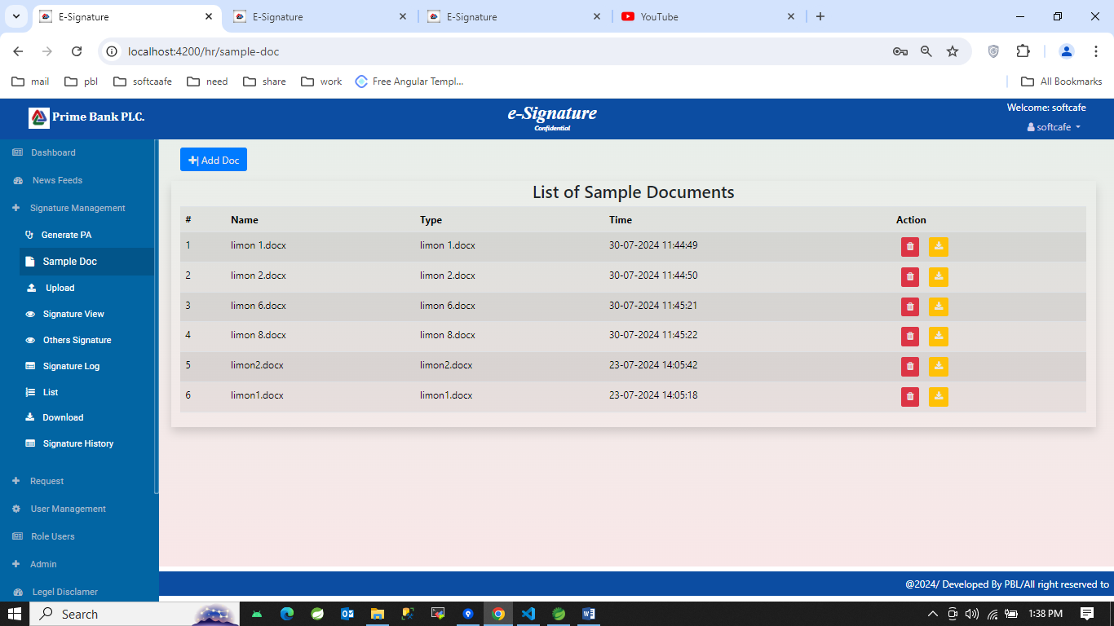

1. Clicking add doc button:

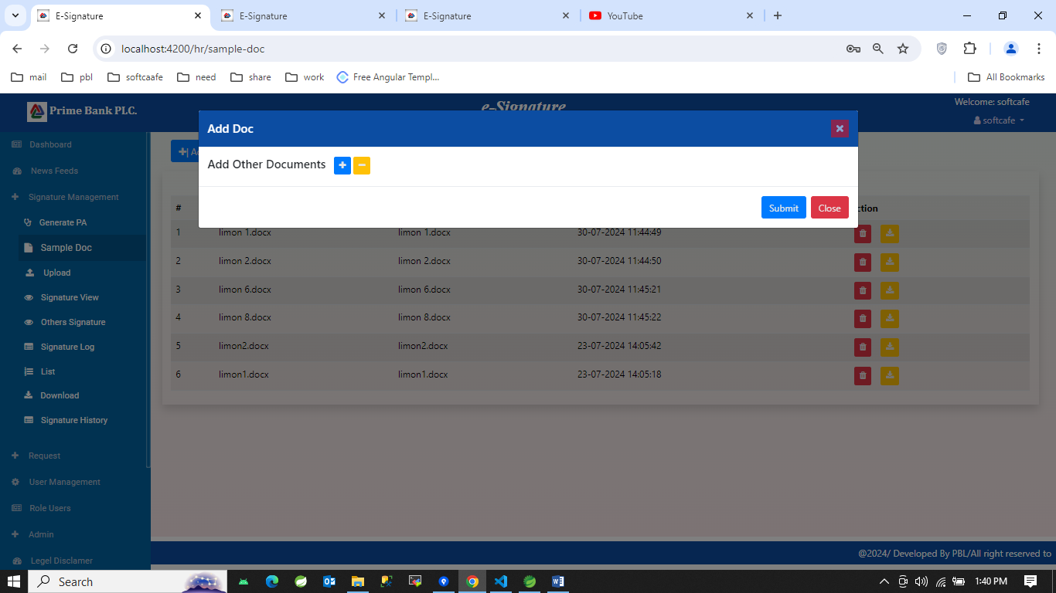

1. Clicking plus button:

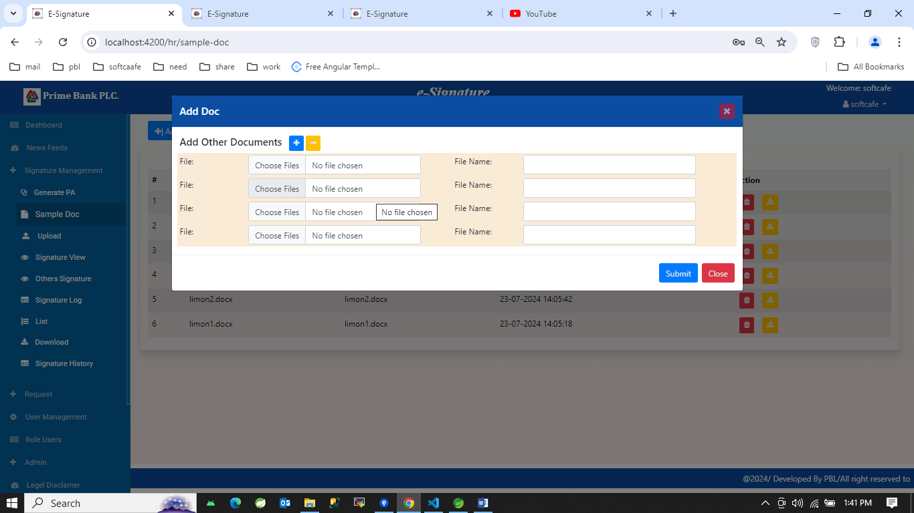

1. Upload section:
2. 1st look:

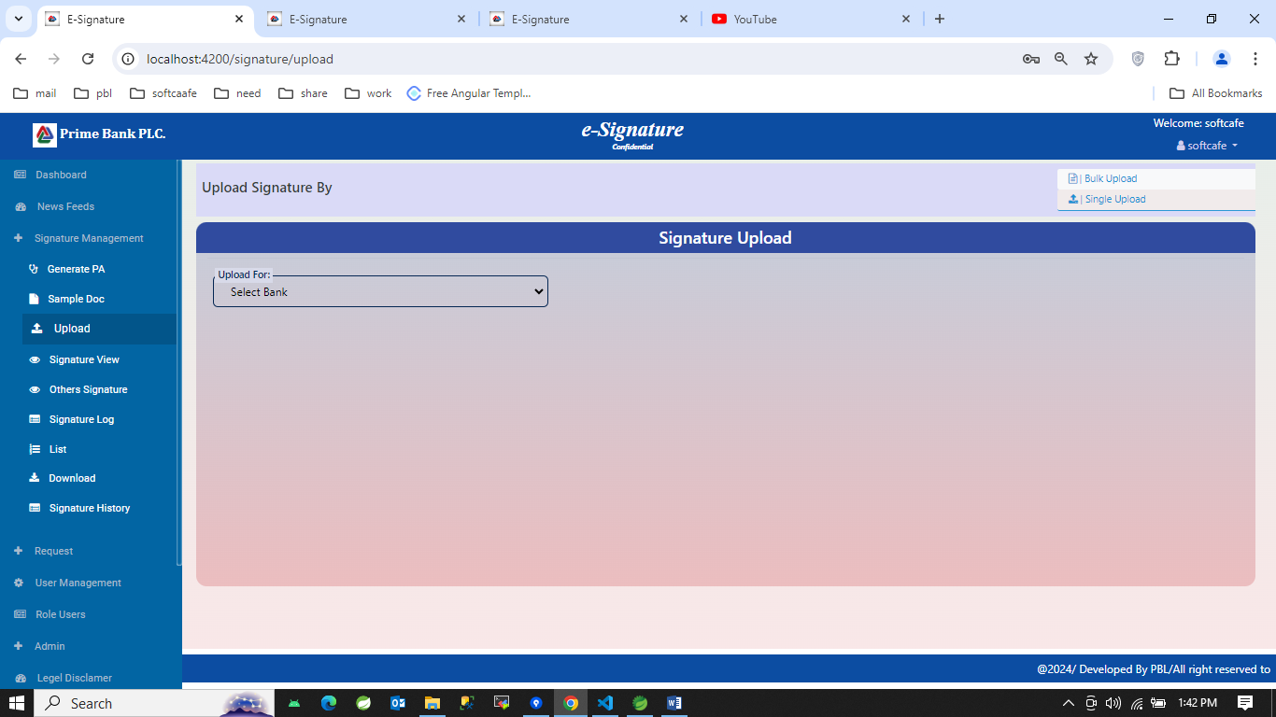

1. 2nd look: Clicking Bulk upload button

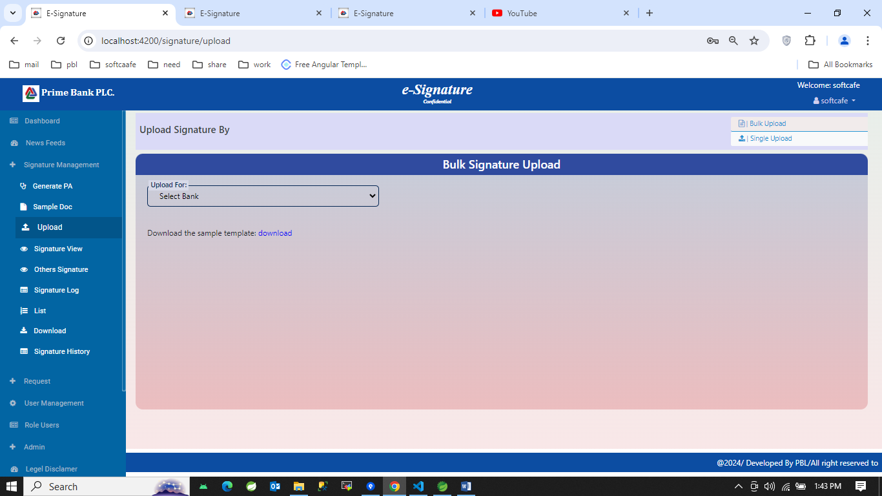

1. Selecting all the information in single upload: Upload for Prime Bank

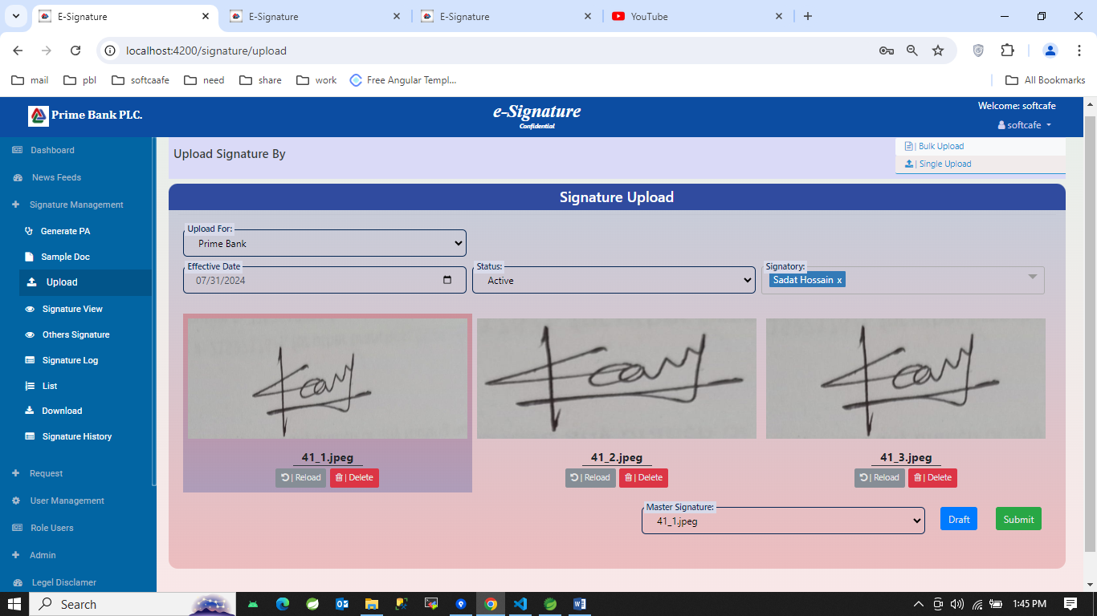

1. Selecting all the information in single upload: Upload for Others Bank

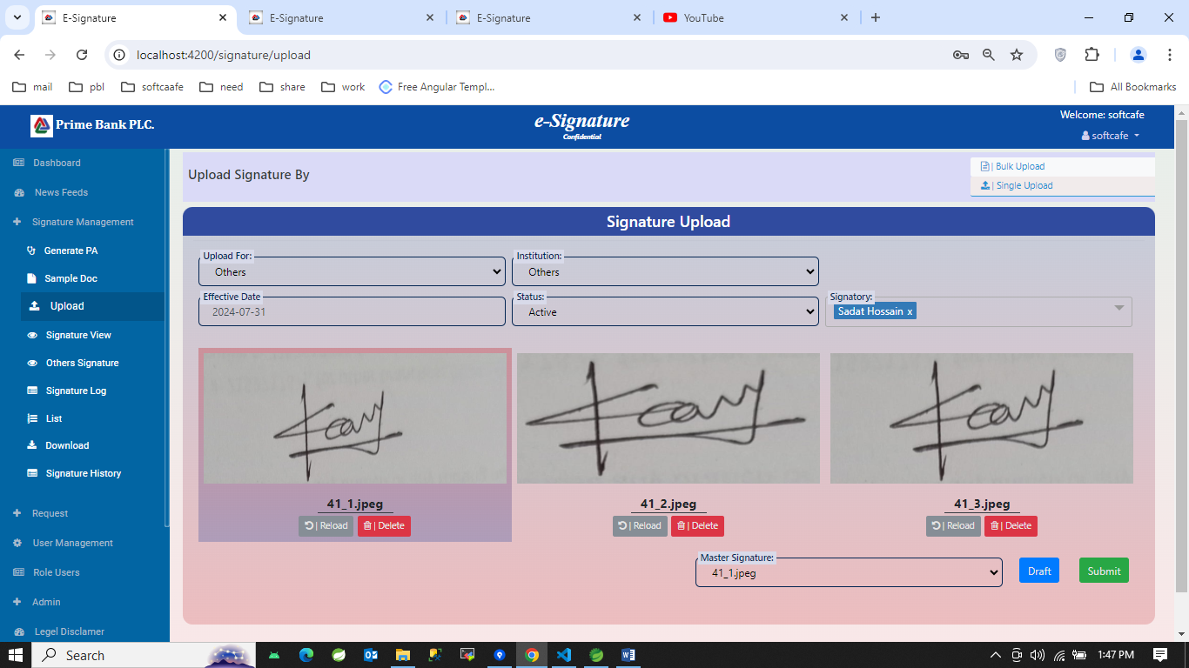

1. View for Prime Bank in Bulk upload section: Selecting Prime Bank in Upload for section

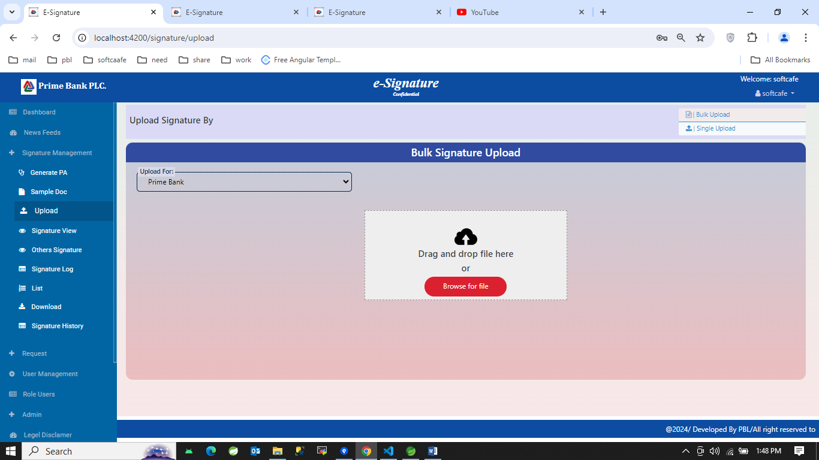

1. View for Prime Bank in Bulk upload section: Selecting Others in Upload for section and selecting Selection type and institution Name

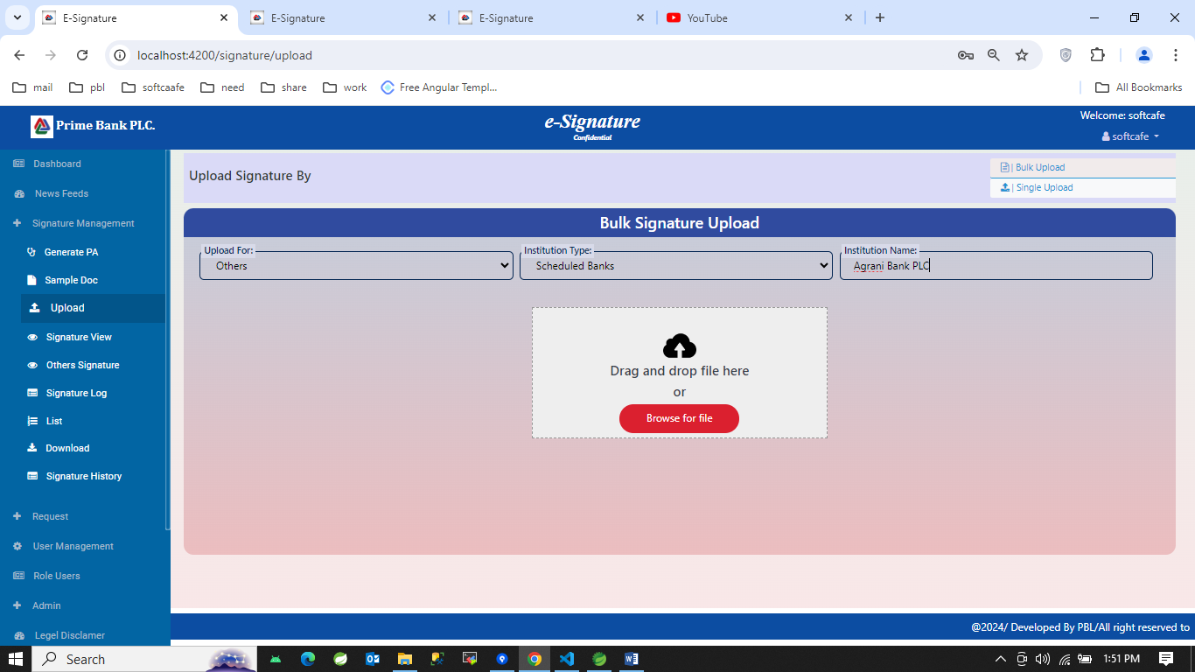

1. Signature Log section:

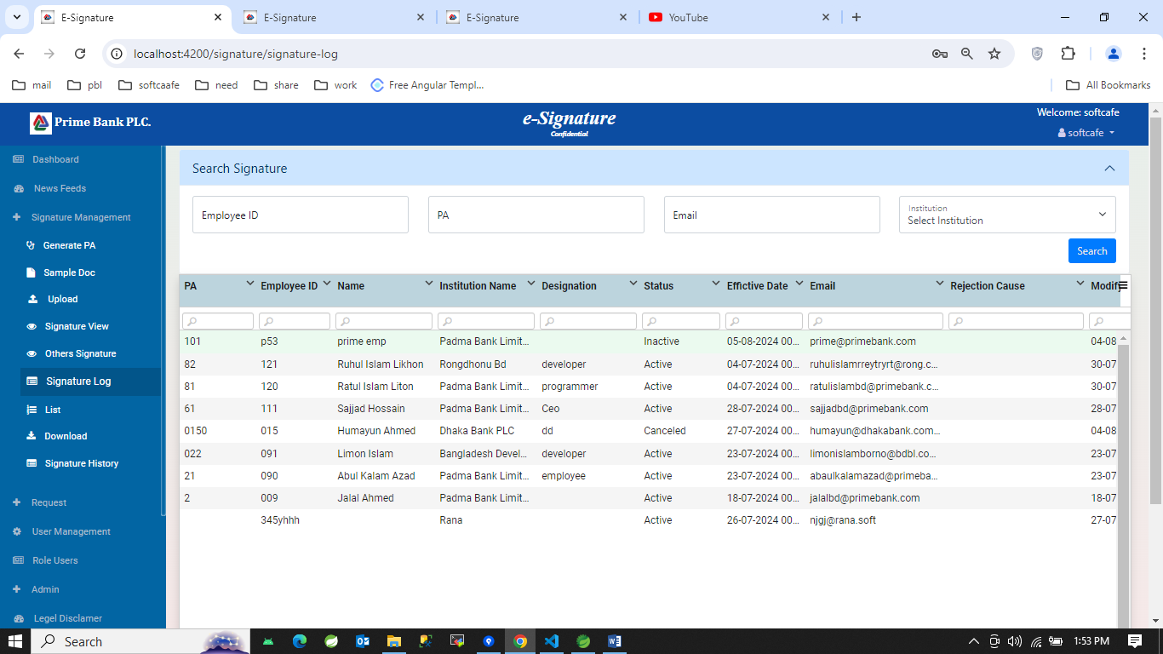

1. List section:

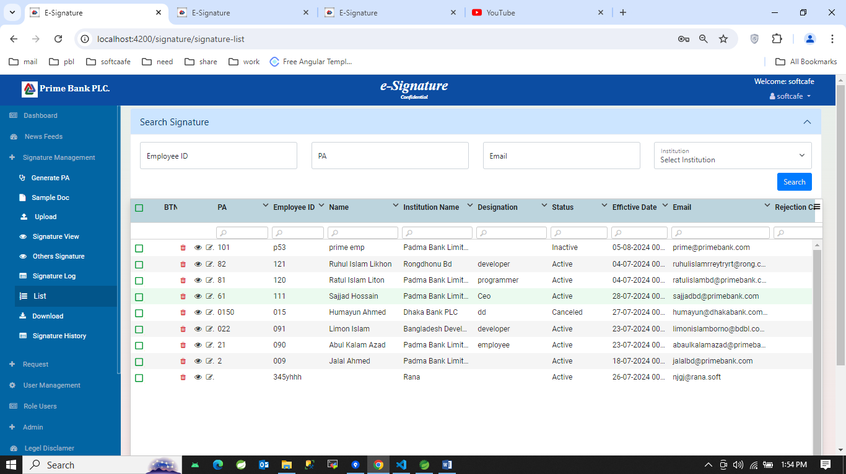

1. Download section:
2. 1st look:

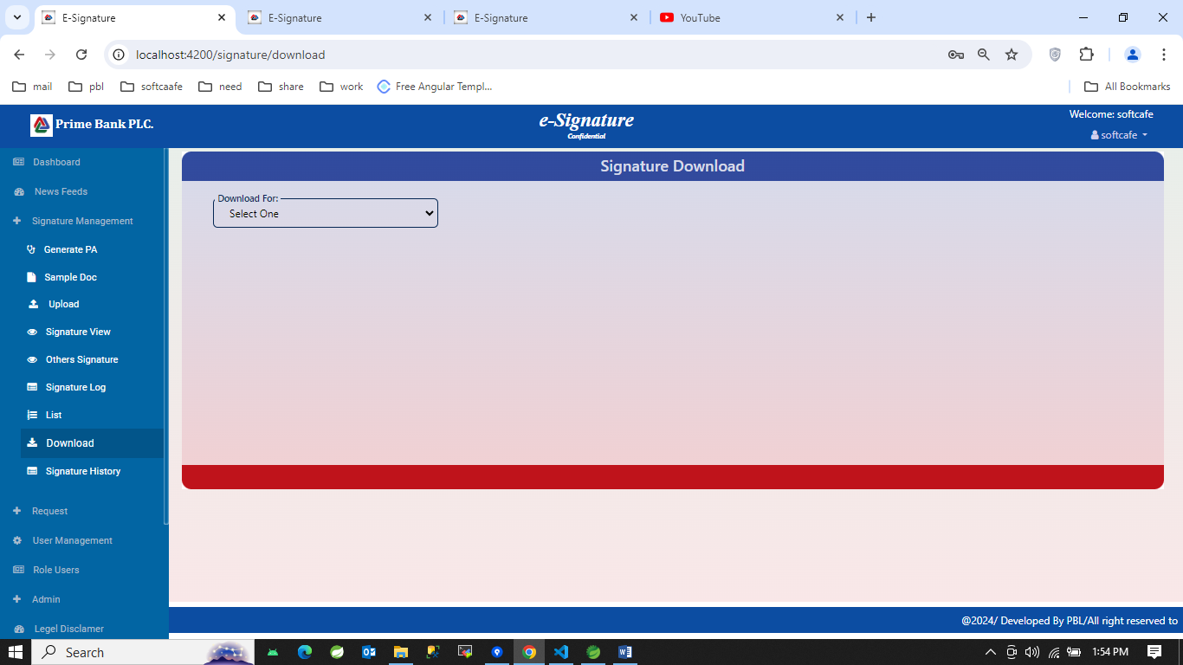

1. 2nd look:

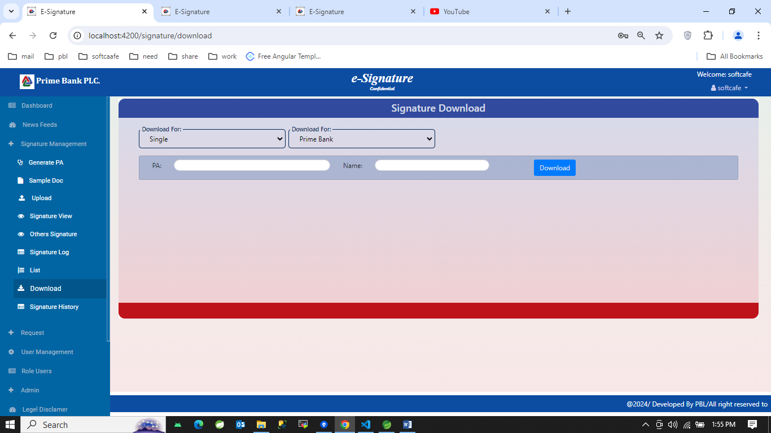

1. 3rd look:

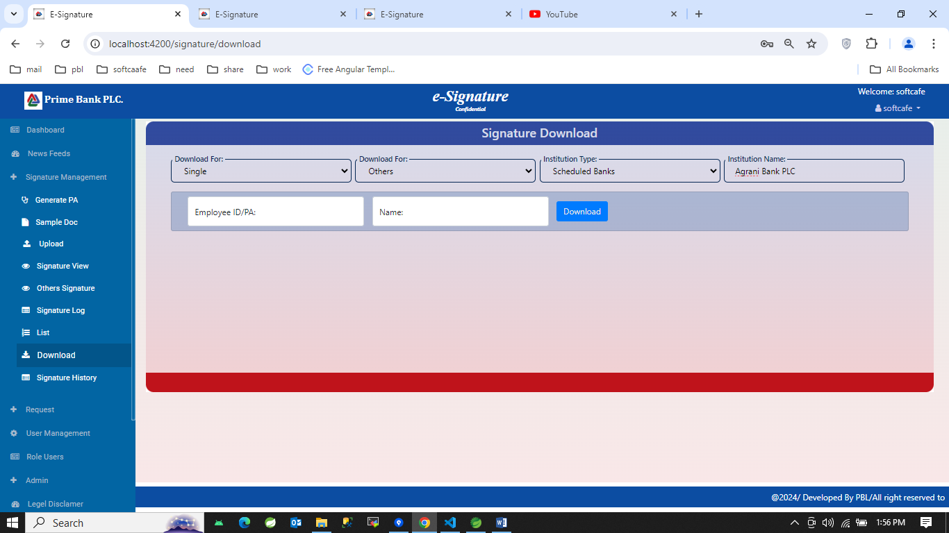

1. 4th look: insert all the required information and clicking Download button

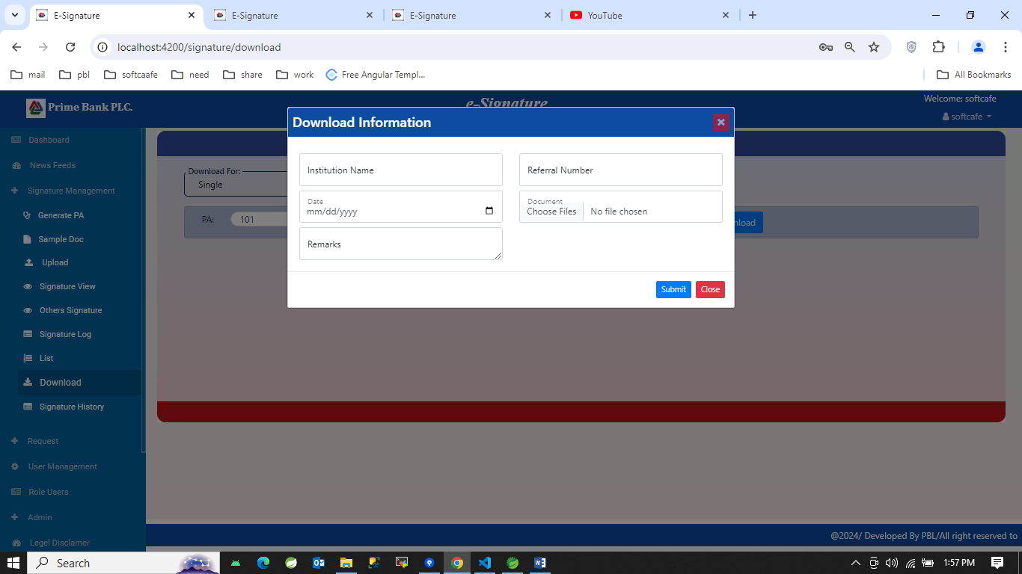

1. Signature history:
2. 1st look:

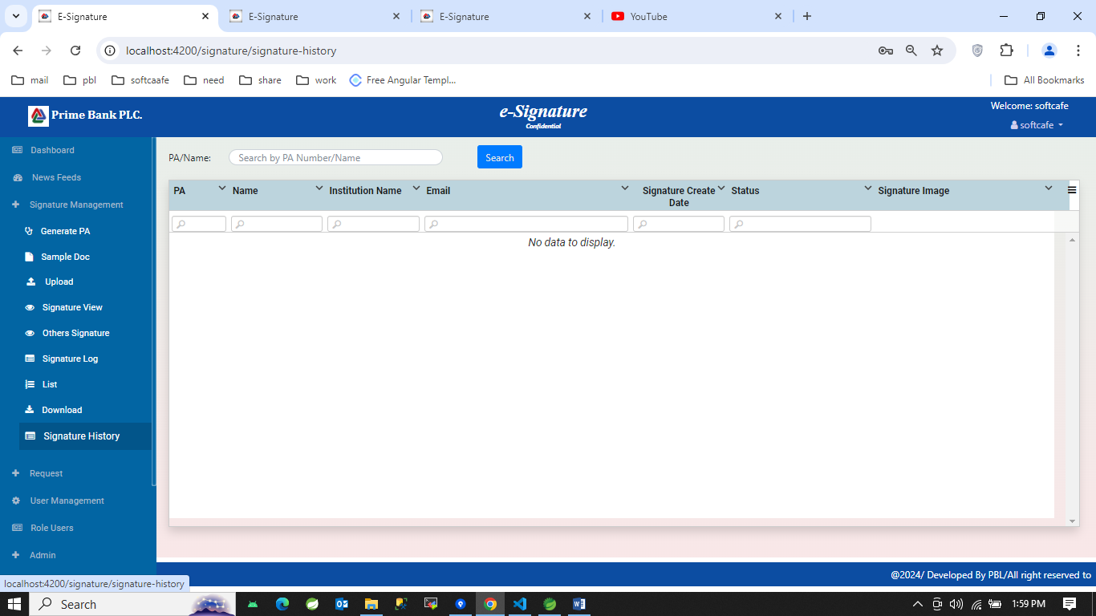

1. 2nd look: After search

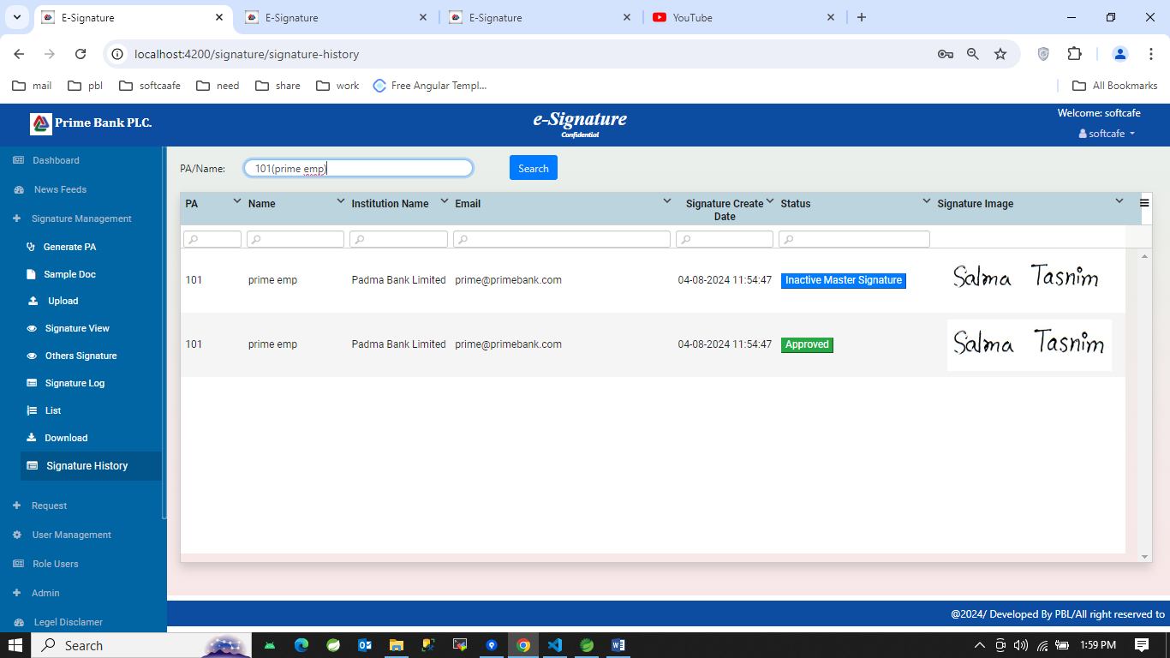

1. Add user section:
2. 1st look:

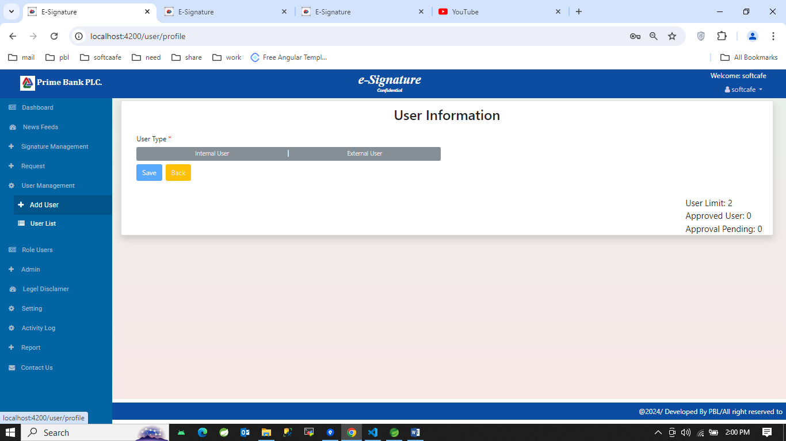

1. 2nd look: selecting Internal User

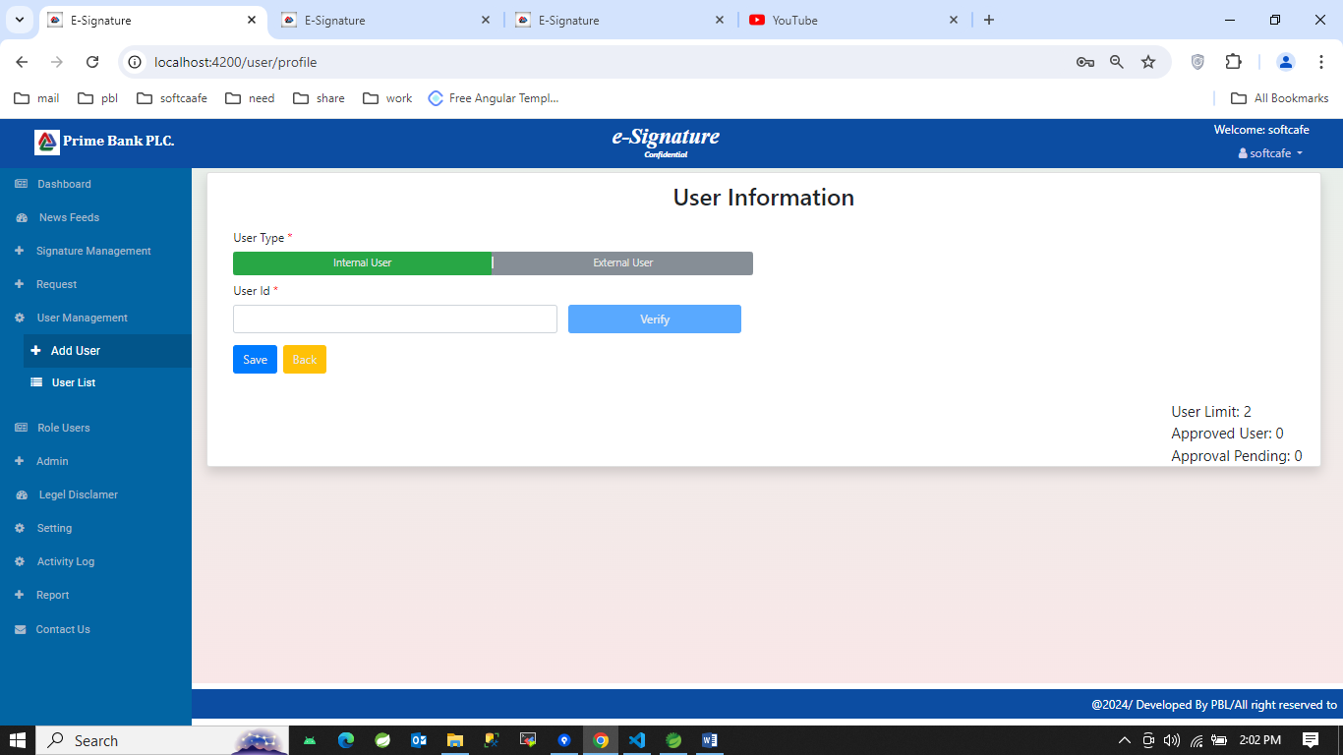

1. 3rd look: selecting External user

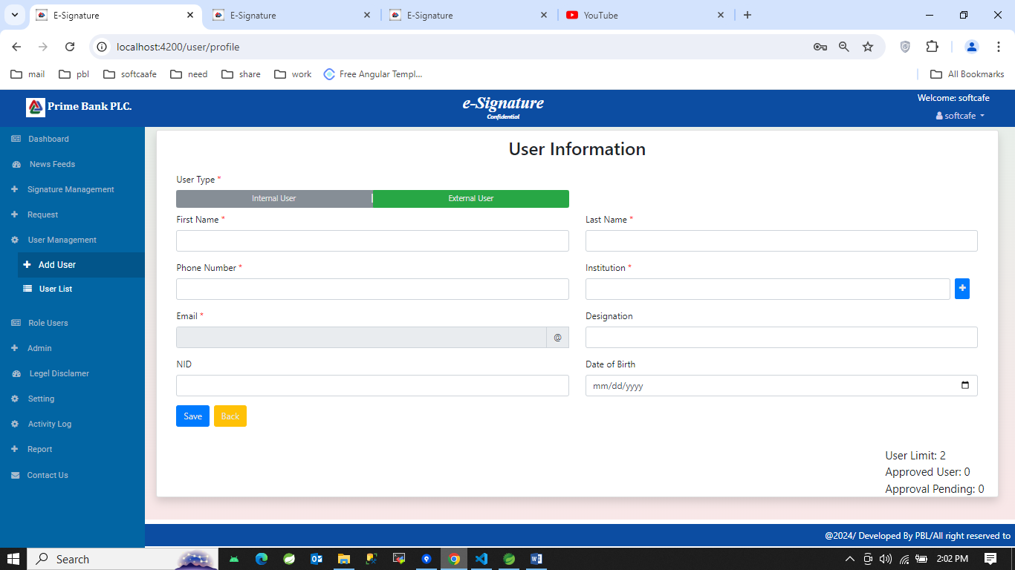

1. User list section:
2. 1st look:

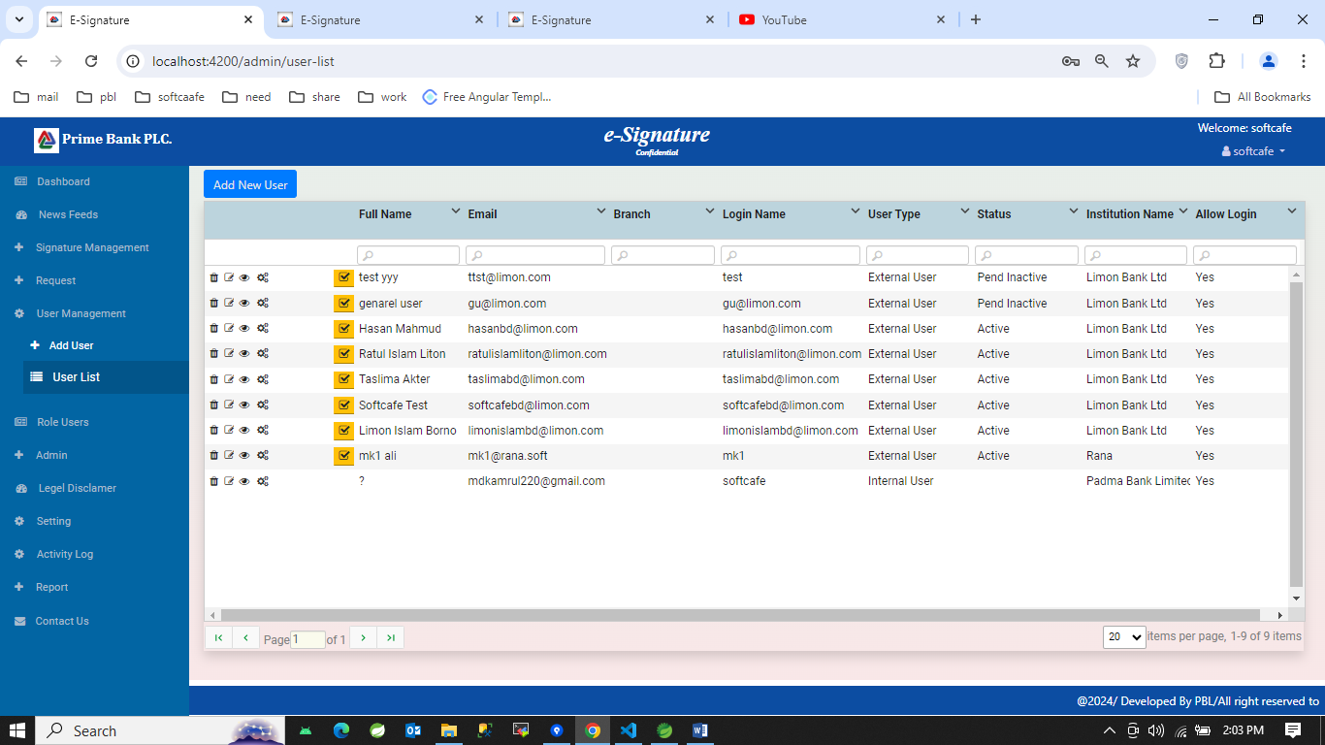

1. Role selection:

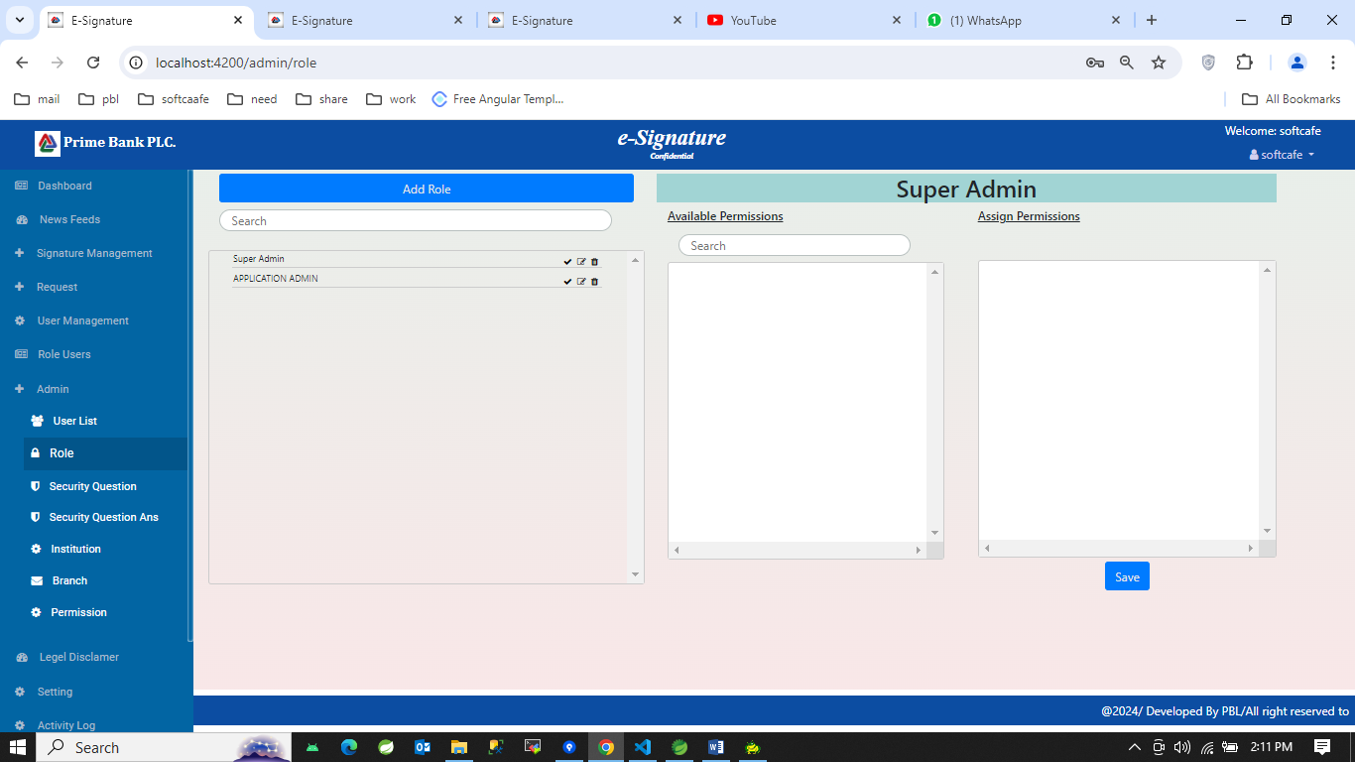

1. Security question section:
2. 1st look:

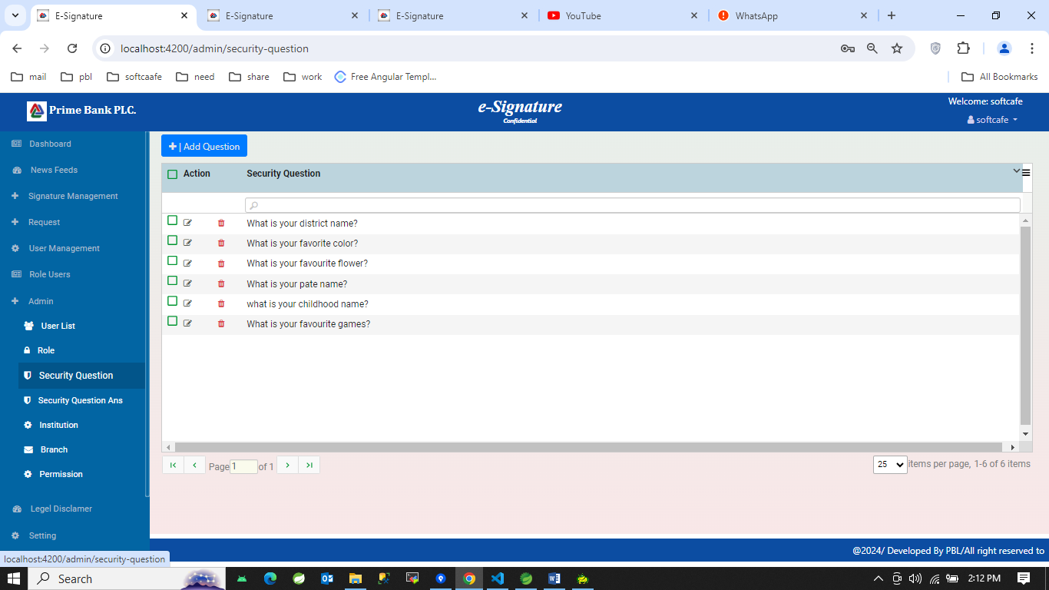

1. 2nd look: clicking add button

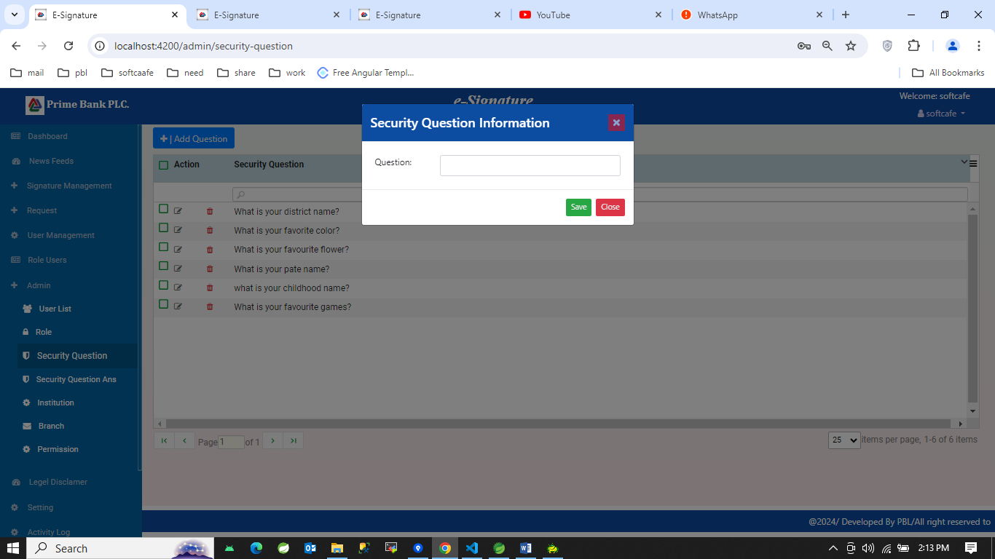

1. Security question answer:
2. 1st look:

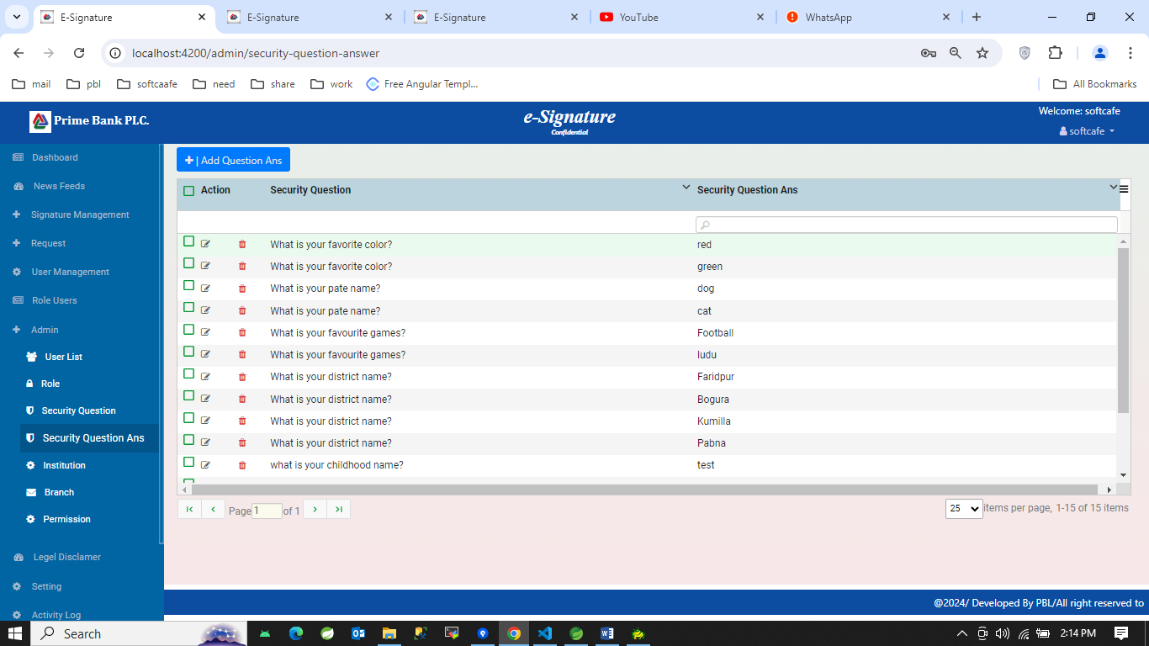

1. 2nd look: clicking add button

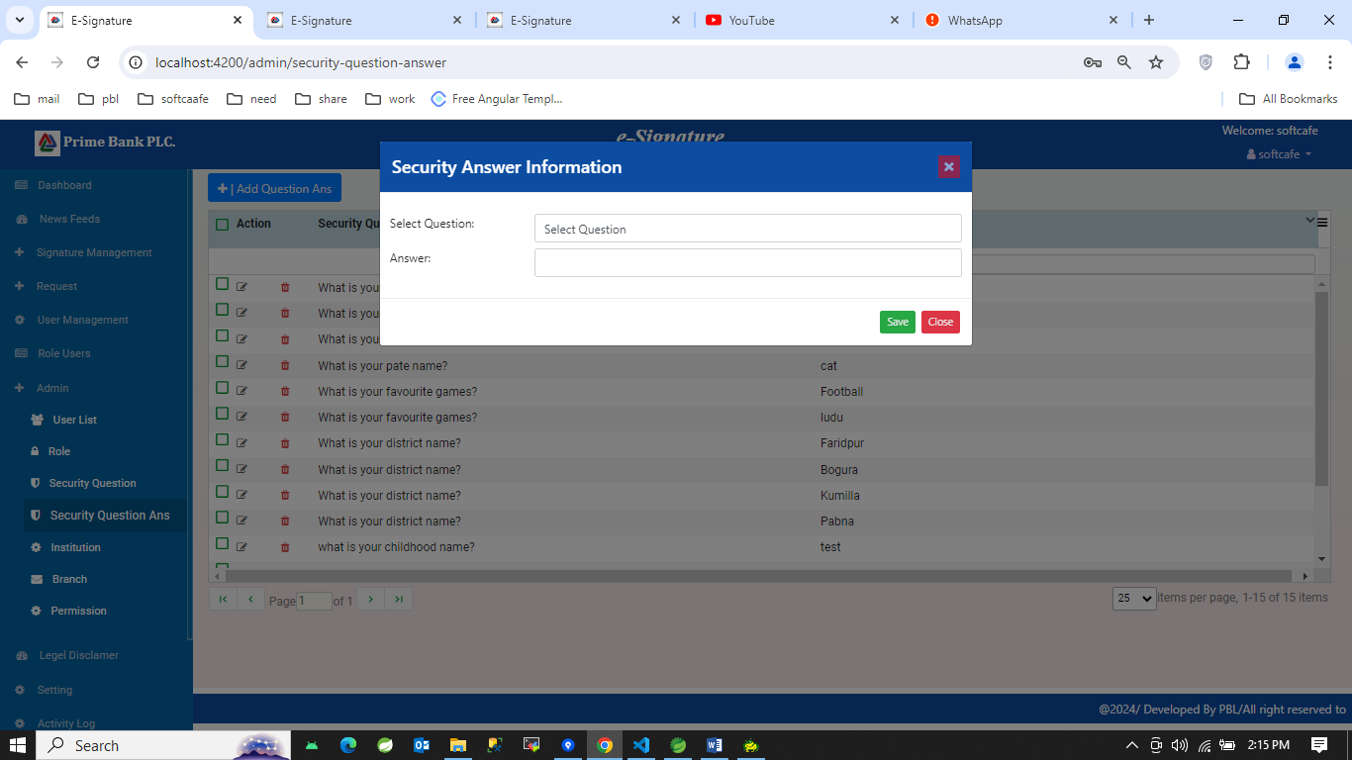

1. Institution section:
2. 1st look:

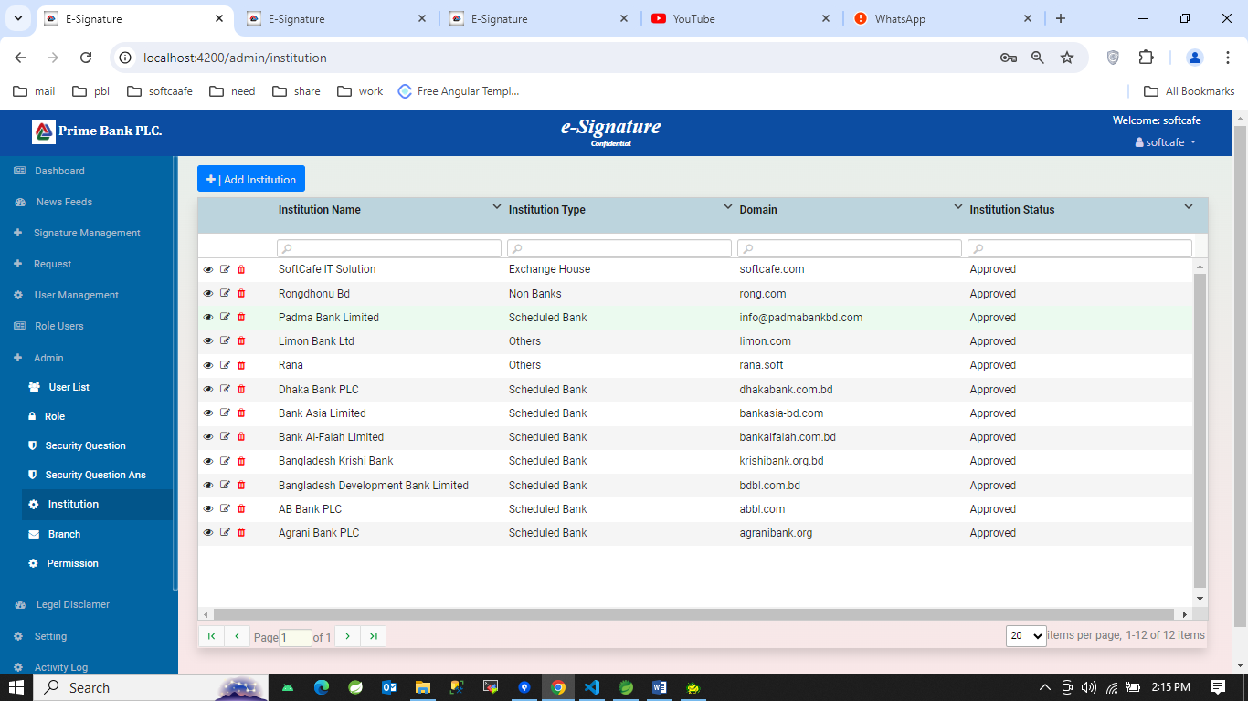

1. 2nd look:

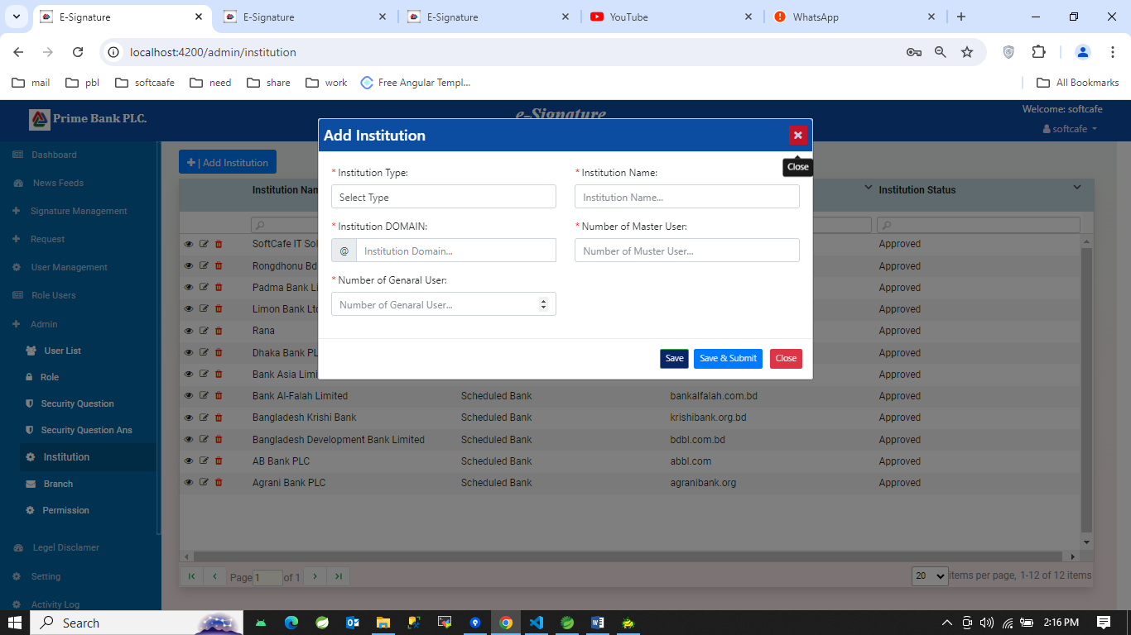

1. Branch section:
2. 1st look:

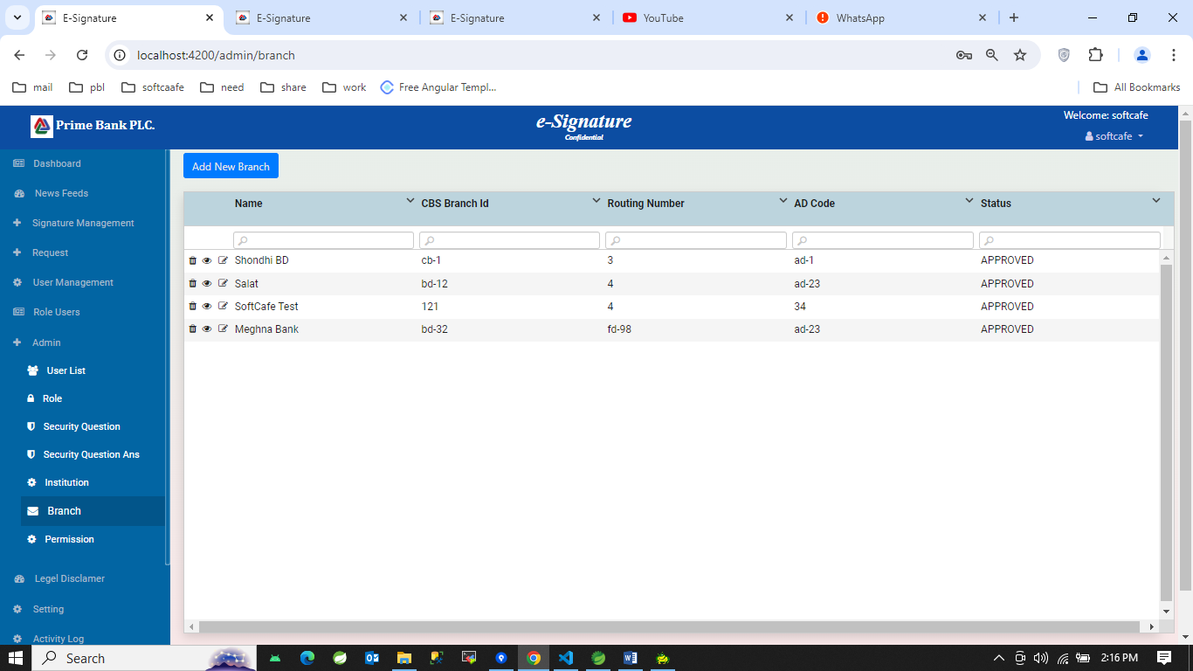

1. 2nd look:

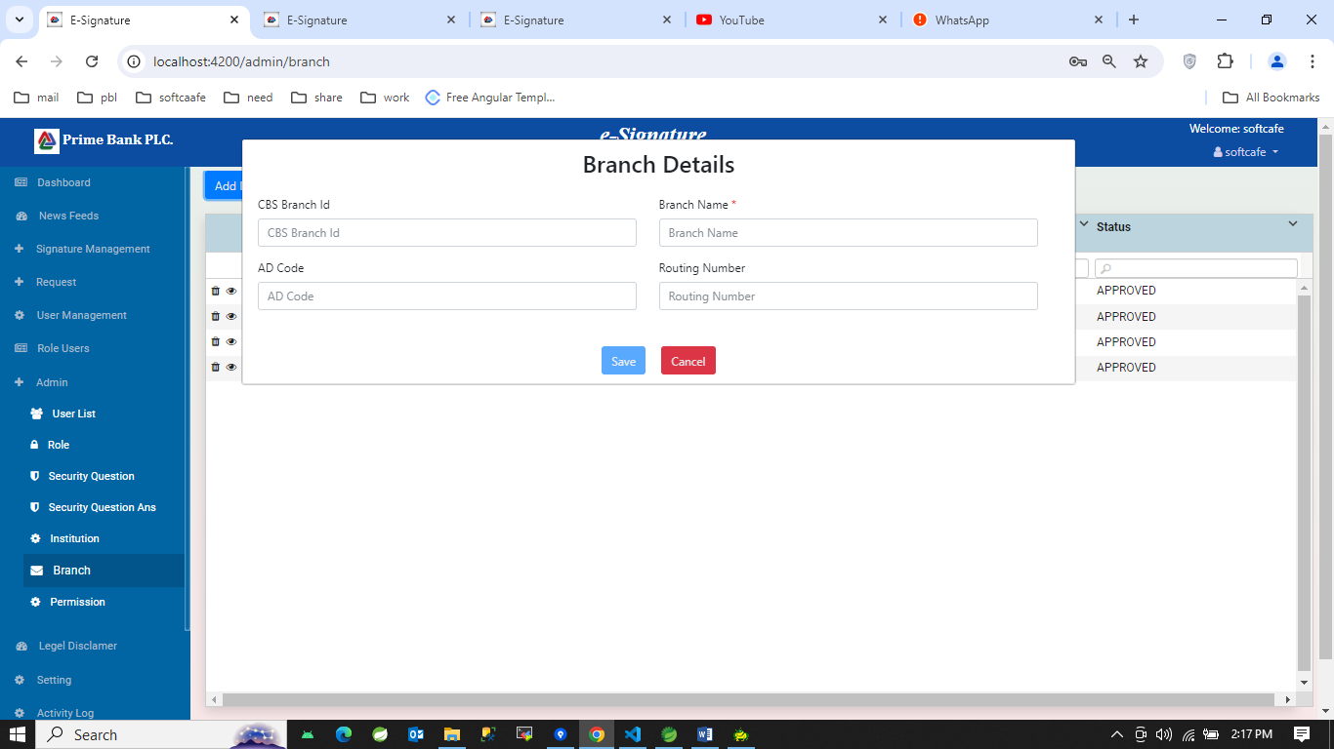

1. Permission section:

